How does layering improve learning and cognitive load?
Layering and cognitive load
Learning in layers is one of the most powerful principles you can integrate into your learning system. It makes large volumes of content less overwhelming and more relevant, improves retention, and creates deeper mastery.
One of the reasons for this is that learning in layers optimises your cognitive load. Understanding how layering improves learning at a theoretical level helps you self-diagnose and adapt your learning if it isn't as effective as you want it to be.
Progression note
This article is most relevant for those who are in at least Ascent 2 of the program. If you have not reached this stage yet, this article may be overwhelming or irrelevant.
How our brain learns
In the early phases of learning a new topic, our brain needs a big-picture frame of relevance. It needs to know why it should care about the new information we're about to consume.
When we discussed prestudying, we were able to split the cognitive load across multiple focused sessions to build the big picture, give ourselves more relevance, and increase our efficiency.
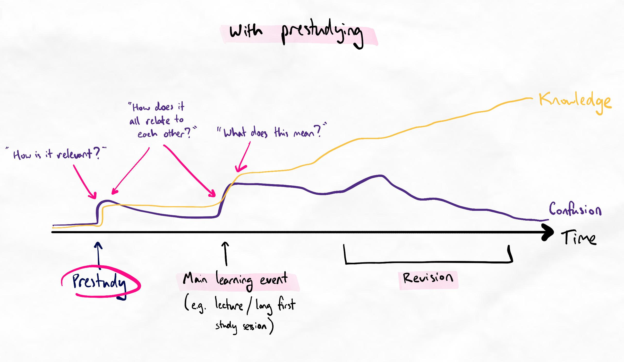
Cognitive load on creating knowledge structures is spread over time.
Learning in layers takes this to the next level by giving our order control and inquiry process a clearer focus.
By creating focused layers, we engage in what is called self-regulated scaffolding, which is when we teach ourselves by deconstructing a topic and reconstructing it in a way that is easier and more manageable for us to understand and develop expertise.
Representing this visually makes it easier to see what learning in layers helps us to achieve.
How knowledge is structured
Knowledge and expertise are inherently structured in layers. For many, the formation and discovery of these layers come after years of learning. While it certainly takes time and dedication for expertise to build, this process can be massively expedited by deliberately targeting our learning on each layer.
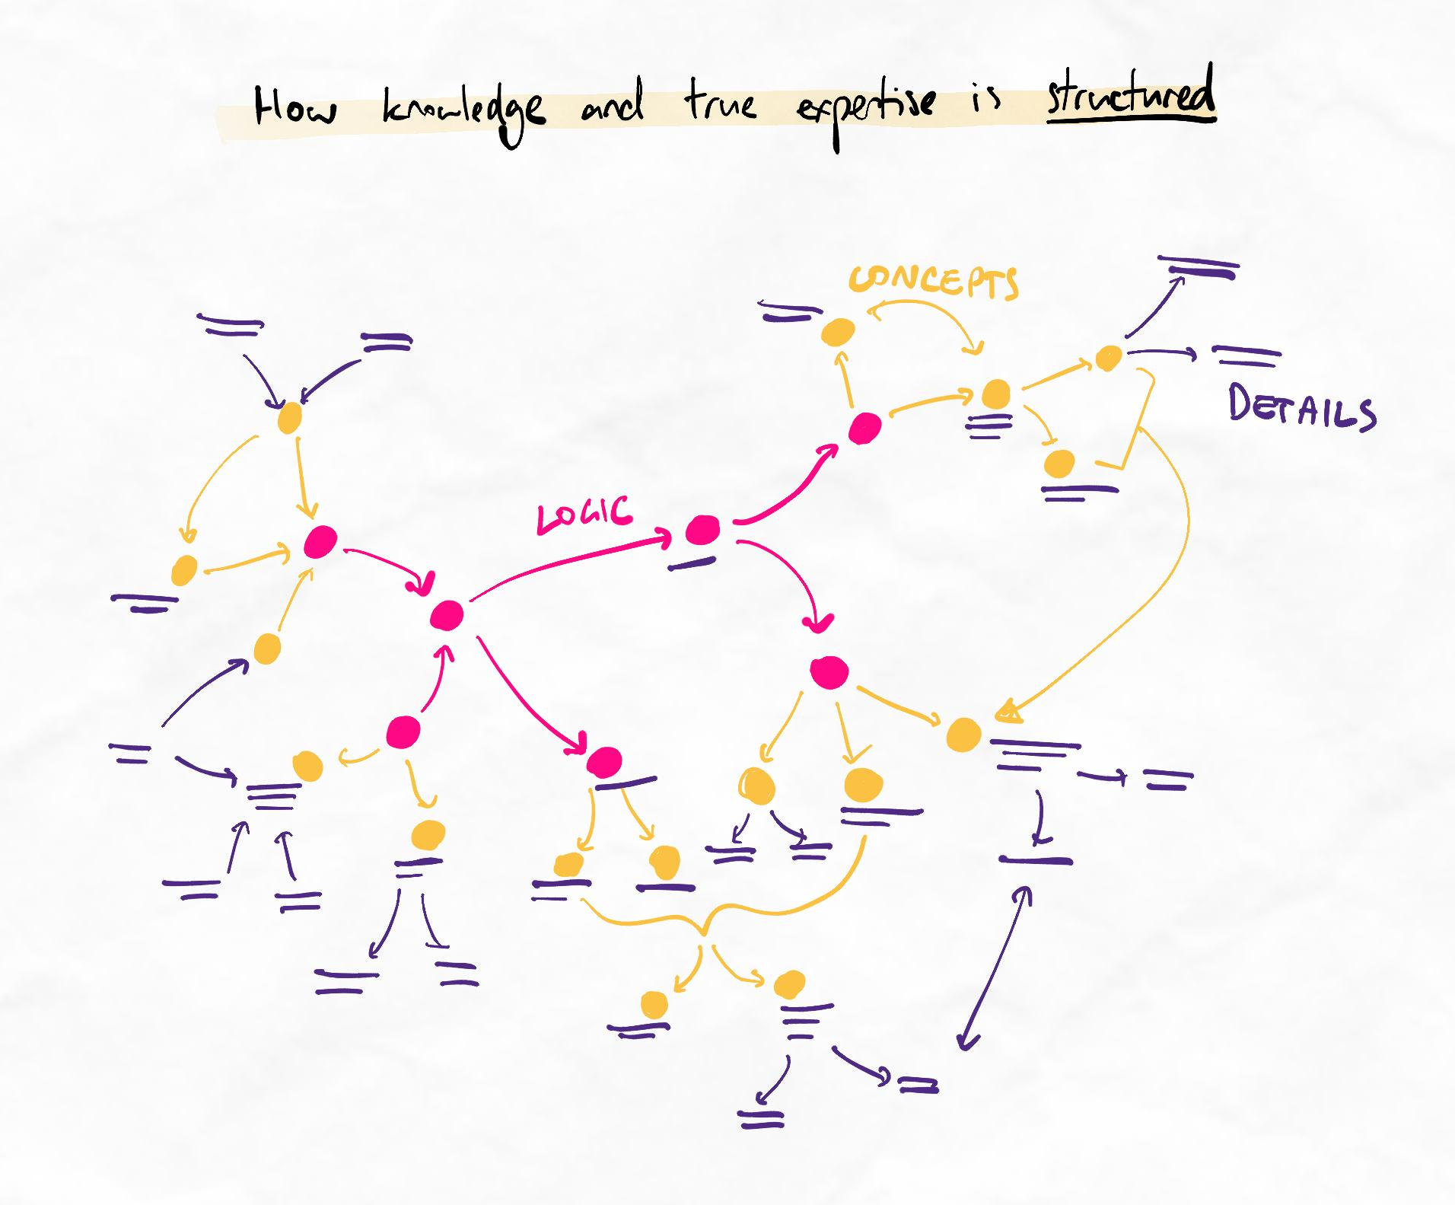
Notice how true expertise is organised, multi-directional, non-linear, and grouped. This is true of any expertise for any knowledge domain.
How knowledge is often taught
Knowledge is often presented in a mix of layers. Details and concepts are interspersed with infrequent hints to logic. Learning in the same order, without order control, creates cognitive overload as our brain struggles to make the information relevant.
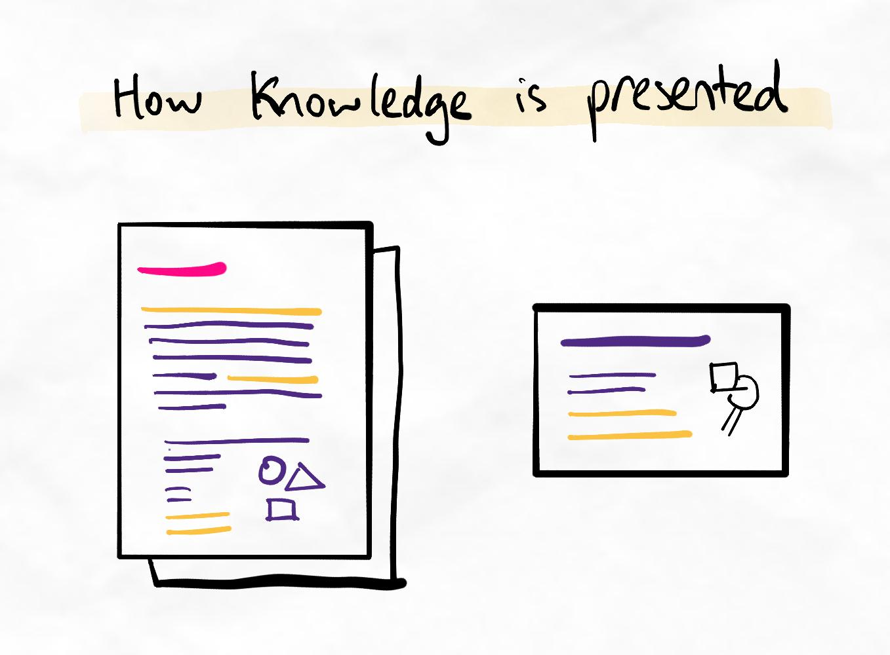The logic and concepts are sometimes not represented in headings either.
As learners, we must strategically apply our cognitive load to extract and make judgments on the layers. The contents of each layer are usually not explicitly given to you. We must construct these ourselves using the methods of chunking we have already practised.
Sometimes, the apparent "logic" in our resources is not the best chunk to use after independently evaluating using our importance-based chunking process.
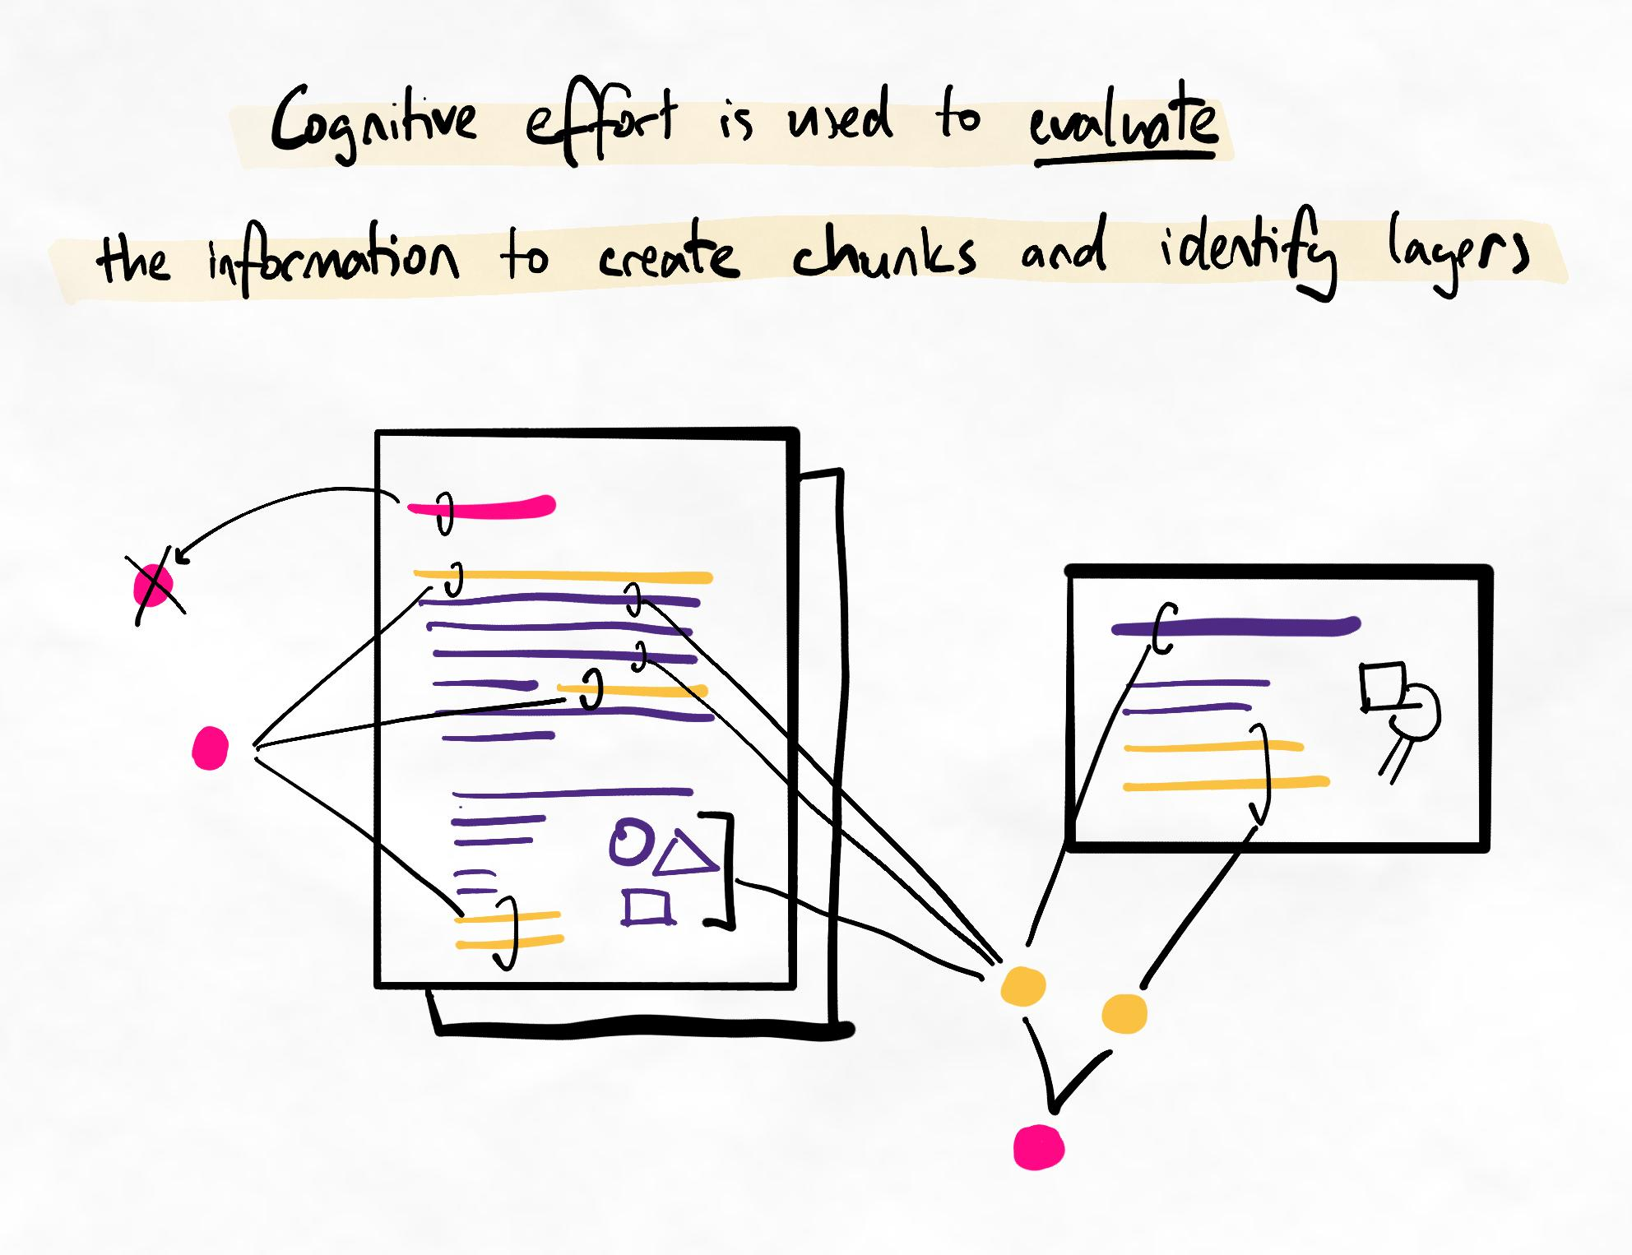The process of moving between resources is order control. The desired outcome is to identify layers of learning.
What our brain is doing
As we have already learned, we should always utilise order control to find the most relevant information first. Once we have a foundation of relevant information, we can find the next set of more detailed relevant information. Continuing this process helps us build a comprehensive knowledge structure.
As shown in the graph below, conventional methods of learning take in information that is usually at a high level of detail very early. The relevance of information is fluctuating which makes it difficult for our brain to create a model of knowledge. Therefore, the difficulty of learning is high throughout. This is tiring and inefficient.
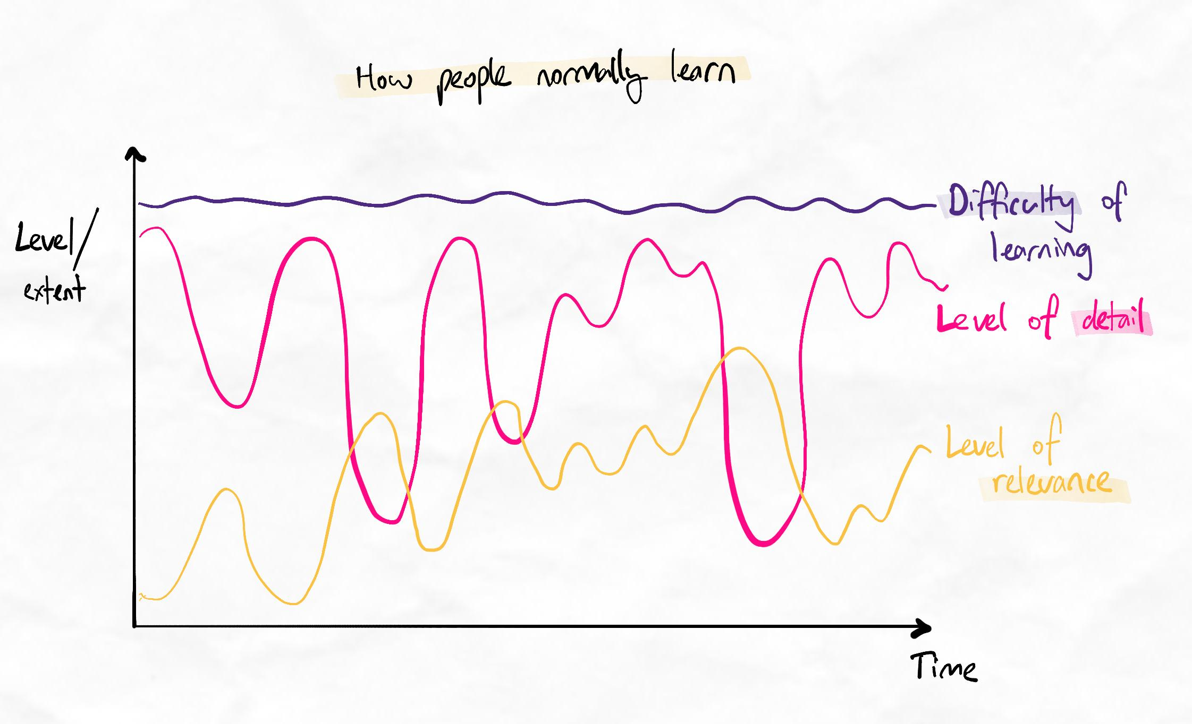Notice how seemingly random the journey of learning a new topic is with conventional methods.
Instead, by learning in layers, we can invest our cognitive resources more strategically, as follows:
- Spend more effort upfront to identify the logic. This establishes a foundation of relevance.
- Work through increasing layers of detail, continuously moving to the next most relevant piece.
- Over time, the difficulty of learning reduces as our knowledge network becomes more robust.
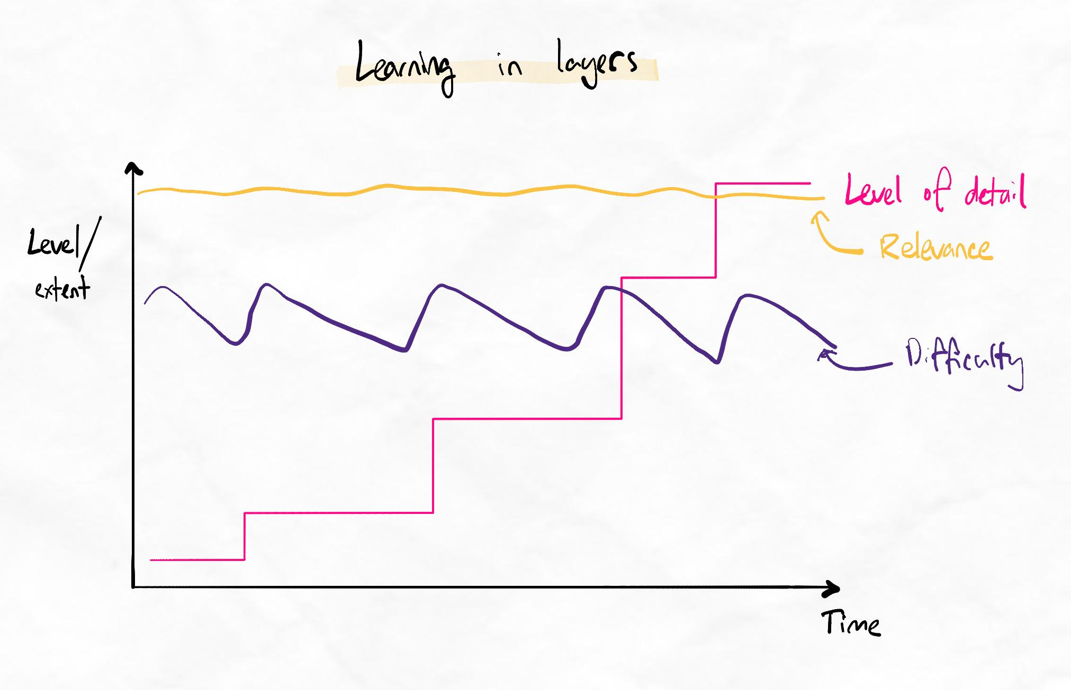We can increase our level of detail layer-by-layer, investing manageable cognitive difficulty and keeping relevance (and therefore effectiveness of learning) high at all times.

